**Project Deliverable 1 - Git Repositories**

**Git repository link:**

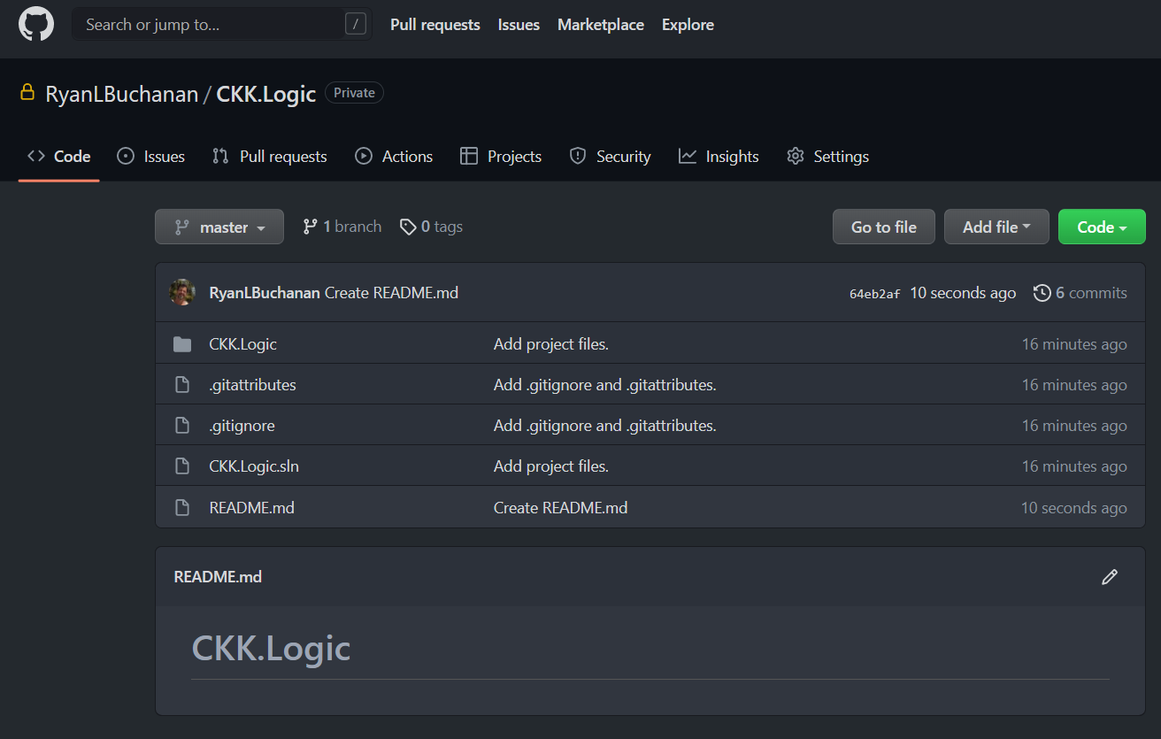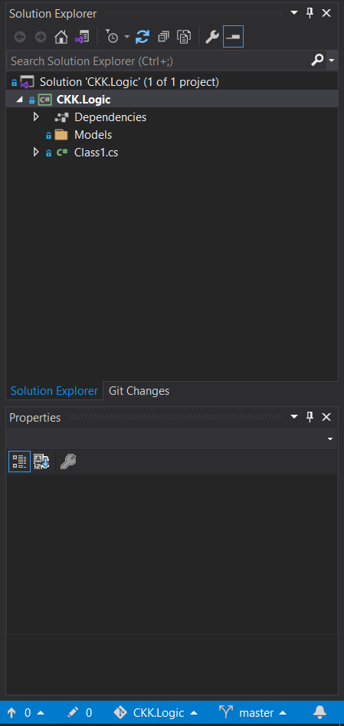**<https://github.com/RyanLBuchanan/CKK.Logic>**

**[](https://github.com/RyanLBuchanan/CKK.Logic)**[](https://github.com/RyanLBuchanan/CKK.Logic)